First Reading – Genesis 12.1-9

The Lord said to Abram, ‘Go from your country and your kindred and your father’s house to the land that I will show you. I will make of you a great nation, and I will bless you, and make your name great, so that you will be a blessing. I will bless those who bless you, and the one who curses you I will curse; and in you all the families of the earth shall be blessed.’
So Abram went, as the Lord had told him; and Lot went with him. Abram was seventy-five years old when he departed from Haran. Abram took his wife Sarai and his brother’s son Lot, and all the possessions that they had gathered, and the persons whom they had acquired in Haran; and they set forth to go to the land of Canaan. When they had come to the land of Canaan, Abram passed through the land to the place at Shechem, to the oak of Moreh. At that time the Canaanites were in the land. Then the Lord appeared to Abram, and said, ‘To your offspring I will give this land.’ So he built there an altar to the Lord, who had appeared to him. From there he moved on to the hill country on the east of Bethel, and pitched his tent, with Bethel on the west and Ai on the east; and there he built an altar to the Lord and invoked the name of the Lord. And Abram journeyed on by stages towards the Negeb.
Psalm – 33.1-12
Response: Happy the people the Lord has chosen as his own!
Rejoice in the Lord, you righteous;
it is good for the just to sing praises.
Praise the Lord with the harp;
play to him on the psaltery and the lyre.
Sing for him a new song;
sound a fanfare with all your skill upon the trumpet. R
For the word of the Lord is right,
and all his works are sure.
He loves righteousness and justice;
the loving-kindness of the Lord fills the whole earth. By the word of the Lord were the heavens made, by the breath of his mouth all the heavenly hosts. R

He gathers up the waters of the ocean
as in a water-skin and stores up the depths of the sea.
Let all the earth fear the Lord;
let all who dwell in the world stand in awe of him. For he spoke, and it came to pass;
he commanded, and it stood fast. R
The Lord brings the will of the nations to nought;
he thwarts the designs of the peoples.
But the Lord’s will stands fast for ever,
and the designs of his heart from age to age.
Happy is the nation whose God is the Lord,
happy the people he has chosen to be his own. R

Second Reading – Romans 4.13-25

The promise that Abraham would inherit the world did not come to Abraham or to his descendants through the law but through the righteousness of faith. If it is the adherents of the law who are to be the heirs, faith is null and the promise is void. For the law brings wrath; but where there is no law, neither is there violation.
For this reason it depends on faith, in order that the promise may rest on grace and be guaranteed to all his descendants, not only to the adherents of the law but also to those who share the faith of Abraham (for he is the father of all of us, as it is written, ‘I have made you the father of many nations’)—in the presence of the God in whom he believed, who gives life to the dead and calls into existence the things that do not exist. Hoping against hope, he believed that he would become ‘the father of many nations’, according to what was said, ‘So numerous shall your descendants be.’ He did not weaken in faith when he considered his own body, which was already as good as dead (for he was about a hundred years old), or when he considered the barrenness of Sarah’s womb. No distrust made him waver concerning the promise of God, but he grew strong in his faith as he gave glory to God, being fully convinced that God was able to do what he had promised.
Therefore his faith ‘was reckoned to him as righteousness.’ Now the words, ‘it was reckoned to him’, were written not for his sake alone, but for ours also. It will be reckoned to us who believe in him who raised Jesus our Lord from the dead, who was handed over to death for our trespasses and was raised for our justification.
Gradual Hymn – 315
Immortal love, forever full

GOSPEL – Matthew 9.9-13, 18-26
As Jesus was walking along, he saw a man called Matthew sitting at the tax booth; and he said to him, ‘Follow me.’ And he got up and followed him.
And as he sat at dinner in the house, many tax-collectors and sinners came and were sitting with him and his disciples. When the Pharisees saw this, they said to his disciples, ‘Why does your teacher eat with tax-collectors and sinners?’ But when he heard this, he said, ‘Those who are well have no need of a physician, but those who are sick. Go and learn what this means, “I desire mercy, not sacrifice.” For I have come to call not the righteous but sinners.’
While he was saying these things to them, suddenly a leader of the synagogue came in and knelt before him, saying, ‘My daughter has just died; but come and lay your hand on her, and she will live.’ And Jesus got up and followed him, with his disciples. Then suddenly a woman who had been suffering from haemorrhages for twelve years came up behind him and touched the fringe of his cloak, for she said to herself, ‘If I only touch his cloak, I will be made well.’ Jesus turned, and seeing her he said, ‘Take heart, daughter; your faith has made you well.’ And instantly the woman was made well. When Jesus came to the leader’s house and saw the flute-players and the crowd making a commotion, he said, ‘Go away; for the girl is not dead but sleeping.’ And they laughed at him. But when the crowd had been put outside, he went in and took her by the hand, and the girl got up. And the report of this spread throughout that district.
Intercessions - Nicola Irwin

Offertory Hymn – 343
Jesus, lover of my soul

Post Communion Prayer
O God, we have shared in the mysteries of the body and blood of Christ. Nourish us by this feast that we may live the risen life and serve you faithfully in the world. We ask this in the name of Jesus Christ our Lord. Amen

Recessional Hymn – 19
All my hope on God is founded

St Margaret’s Church
Aberlour

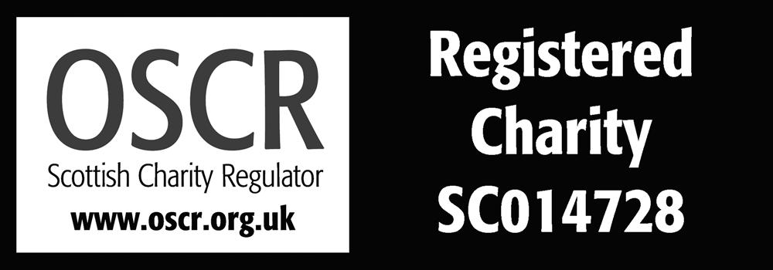

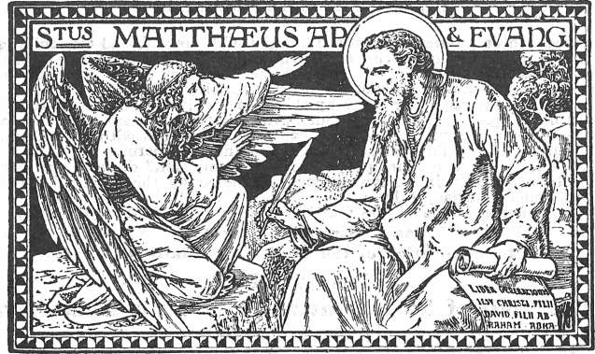

Welcome to the
Scottish Episcopal Church

We welcome members of other
denominations to share in our worship

If you would like to receive Communion with us please come to the altar where all are welcome

Sunday 7th June – Pentecost 2
10am – Eucharist
Rev Ian Sykes

Readings for next Sunday – Pentecost 3
First reading – Genesis 18.1-15,21.1-7
Psalm 116.1, 10-17
Second reading – Romans 5.1-8
Gospel – Matthew 9.35-10.23
Processional Hymn – 205
Glorious things of thee are spoken

Collect
O God, our hope and strength, the source and end of all our prayers: because our mortal nature is weak we can do nothing good without your help; support us with your grace, that in keeping your commandments,
we may ever remain in your love; through Jesus Christ, our Lord, who lives and reigns with you, in the unity of the Holy Spirit, one God, world without end. Amen

www.stmargaretsaberlour.co.uk

